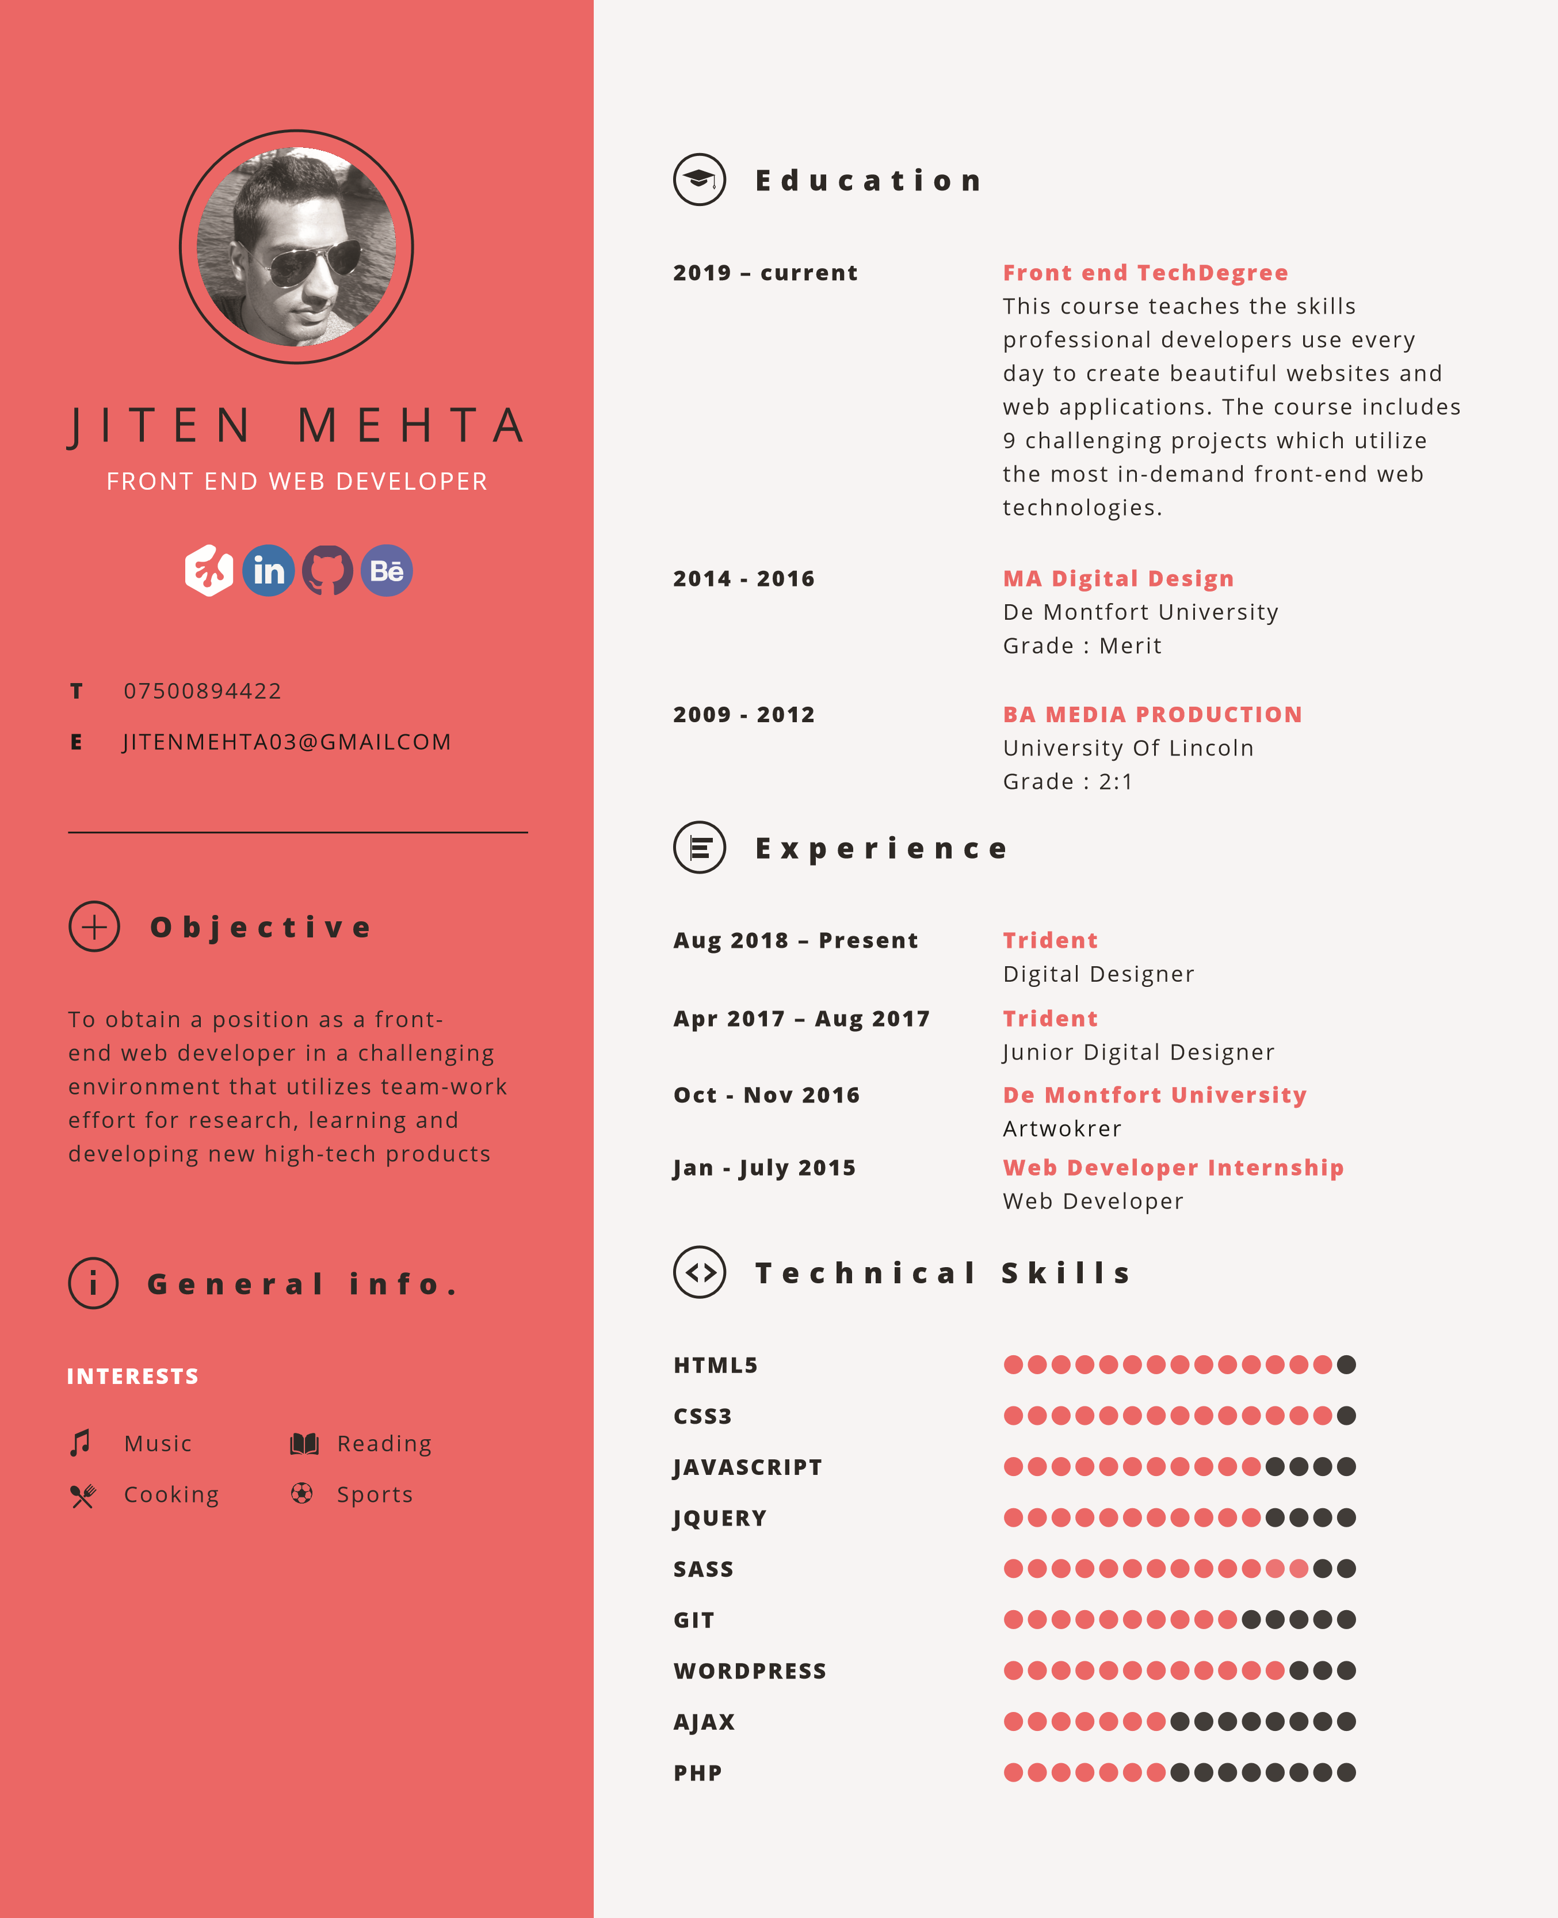

**GIT HUB PROJECTS**

**E**

JITENMEHTA03@GMAILCOM

**T**

07500894422

JITEN MEHTA

FRONT END WEB DEVELOPER



**General info.**

**O**

**bjective**

To obtain a position as a front-

end web developer in a challenging

environment that utilizes team-work

effort for researching, learning and

developing new high-tech products

**INTERESTS**

Music

Cooking

Reading

Sports



**WEB STYLE GUIDE**

**• HTML**

**• CSS**

**• SASS**

**• RESPONSIVE DESIGN**

**• GIT**

**Game Show App**

**• HTML**

**• CSS**

**• SASS**

**• JAVASCRIPT**

**• DOM MANIPULATION**

**• RESPONSIVE DESIGN**

**• GIT**

**An Interactive**

**Photo Gallery**

**• HTML**

**• CSS**

**• SASS**

**• JAVASCRIPT**

**• RESPONSIVE DESIGN**

**• GIT**

**An Online**

**Registration Form**

**RESPONSIVE**

**LAYOUT DESIGN**

**• HTML**

**• CSS**

**• RESPONSIVE DESIGN**

**• GIT**

**• HTML**

**• CSS**

**• FLEXBOX**

**• RESPONSIVE DESIGN**

**• GIT**

My Github account contains various projects. These projects

utilise the latest front end web technologies.

To view my Github account, click

[**e**](https://github.com/JitenMehta01)

[**her**](https://github.com/JitenMehta01)

.

Below is a few examples of the project you can view on my Github

account.